NOTICE OF A MEETING FOR
THE ELECTION OF CHURCHWARDENS

Parish of Ss. Peter and Paul, Bromley

A meeting for the election of churchwardens will be held in church on 12th day of May 2024 at 11:45AM.

This meeting may be attended by:

- All persons whose names are entered on the church electoral roll of the parish and
- All persons resident in the parish whose names are entered on a register of local government electors by reason of such residence

Signed

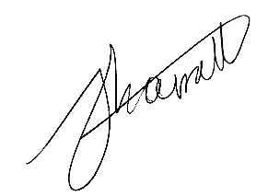

Minister

Dated 17/4/24

In this Notice “parish” means an ecclesiastical parish.

