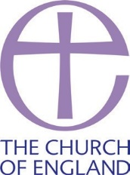
NOTICE OF ANNUAL PAROCHIAL CHURCH MEETING

Parish of Ss. Peter & Paul, Bromley
The Annual Parochial Church Meeting will be held in church
on the 12th day of May 2024.
For election of parochial representatives of the laity as follows –
To the Deanery Synod 2 representatives
To the Parochial Church Council 4 representatives.

For the appointment of the Independent Examiner or Auditor.
For the consideration of:
(a) a report on changes to the Roll since the last annual parochial church meeting
(b) an Annual Report on the proceedings of the parochial church council and the activities of the parish generally;
(c) the financial statements of the council for the year ending on the 31st December preceding the meeting;
(d) other matters of parochial or general Church interest.
In this Notice, ‘parish’ means an ecclesiastical parish.
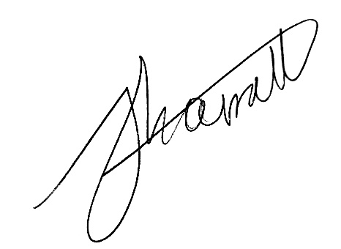
Signed
Minister of the parish

Notes
1 Every lay person whose name is entered on the Church Electoral Roll of the parish (and no other person) is entitled to vote at the election of parochial representatives of the laity.
2 A person is qualified to be elected a parochial representative of the laity if –
(a) his or her name is entered on the Church Electoral Roll of the parish and, unless he or is under 18, has been entered there for at least the preceding six months;
(b) he or she is an actual communicant (which means that he has received Communion according to the use of the Church of England or of a Church in communion with the Church of England at least three times during the twelve months preceding the date of the election);
(c) he or she is at least 16; and
(d) he or she is not disqualified as referred to in paragraph 3 of these Notes.
3 (1) A person is disqualified from being nominated, chosen or elected or from serving as a churchwarden or a member of a parochial church council, a district church council or a joint council if the person is disqualified from being a trustee of a charity (and the disqualification is not subject to a waiver which permits membership of a parochial church council, district church council or joint council).
(2) A person is disqualified from being nominated, chosen or elected or from serving as a member of a parochial church
council, a district church council, a joint council or a deanery synod if the person is included in a barred list (within the meaning of the Safeguarding Vulnerable Groups Act 2006).
(3) A person is disqualified from being nominated, chosen or elected or from serving as a member of a parochial church council, a district church council, a joint council or a deanery synod if the person has been convicted of an offence mentioned in Schedule 1 to the Children and Young Persons Act 1933 (with that expression being construed in accordance with Rule 71(2) of the Church Representation Rules).
(4) A person’s disqualification under sub-paragraph (3) may be waived by the bishop of the diocese by giving the person notice in writing.
(5) A person is disqualified from being nominated, chosen or elected or from serving as a member of a parochial church council if the person has been disqualified from holding office under section 10(6) of the Incumbent (Vacation of Benefices) Measure 1977.
43 A scheme is in operation in this parish which provides that any person entitled to vote in the elections of parochial representatives of the laity to the parochial church council or to the deanery synod or to both may apply on the appropriate form to the Minister of the parish (or other person signing below) for a postal vote. The completed form must be received before the commencement of the annual parochial church meeting.
Notes
1 To be included in a year in which parochial representatives of the laity are to be elected to the Deanery Synod.
2 To be included in a year when a new Church Electoral Roll is prepared. Delete as applicable.
3 This paragraph should be deleted if no scheme for postal voting is in operation in the parish.
4 Or vice-chair of the parochial church council as the case may be (see rule M19(2) of the Church Representation Rules).

